

KAUNAS UNIVERSITY OF TECHNOLOGY

FACULTY OF INFORMATICS

T120B166 Development of Computer Games and Interactive Applications

Escape the Lab VR

**Done by:**

|  |
| --- |
| IFF-7/14 group Airidas Janonis  Eligijus Kiudys |
|  |
| **Date:**  2020-02-17 |

Kaunas, 2019

Tables of Contents

Tables of Images 3

Table of Tables/functions 4

Work Distribution Table: 5

Description of Your Game 6

Laboratory work #1 7

List of tasks 7

Solution 7

Task #1. Create a short introduction level (Airidas) 7

Task #2. Implement Virtual Reality player movement (in this case, teleportation) 12

Task #3. Decorate the level with at least 20 GameObjects, 5 Lights and 5 materials (Airidas) 15

Task #4. Make a new GameObject, give it a Collider, use onTriggerEnter to track when the Player touches it, then destroy it and print out a message that says “Player touched me” (Eligijus) 17

Task #5. Create UI that displays how many objects were touched (Airidas) 18

Literature list 20

ANNEX 21

# **Tables of Images**

Figure 1. The beginning level scene with some used prefabs below 7

Figure 2. Objects inside of a shelf 8

Figure 3. Timer trigger 8

Figure 4. Correct teleportation 12

Figure 5. Incorrect teleportation 13

Figure 6. VRTK Teleportation hierarchy 13

Figure 7. Main teleportation component inspector 14

Figure 8. Scene decoration with various GameObjects 15

Figure 9. Objects used in the scene #1 15

Figure 10. Objects used in the scene #2 16

Figure 11. Objects used in the scene #3 16

Figure 12. Lamp model #1 16

Figure 13. Lamp model #2 17

Figure 14. No objects touched 18

Figure 15. One object touched 18

# **Table of Tables/functions**

Table 1. Timeleft.cs script component 9

Table 2. StopTime.cs script component 10

Table 3. LockUnlockWithKey.cs script component 11

Table 4. destroyontouch script component 17

Table 5. DisplayAtUI script component 19

# **Work Distribution Table:**

|  |  |
| --- | --- |
| ***Name/Surname*** | ***Description of game development part*** |
| *Airidas Janonis* | Mostly responsible for project management, game design, 2D assets (sprites, sprite sheets, etc. ), game balancing, creating visual effects ( unity VFX, particle systems ), a smaller portion of programming |
| *Eligijus Kiudys* | Mostly responsible for a bigger portion of the programming, creating some of the 3D assets, implementing new systems into the game (Steam VR, Virtual reality toolkit VRTK, etc.), shader writing for game mechanics such as drawing, writing, creating some of visual effects. |

# **Description of Your Game**

Description of Your Game.

1. **2D or 3D?** 3D.
2. **Genres:** Casual, Indie, Simulation, Educational
3. **Platforms:** PC
4. **Scenario Description:** The main concept of the game was taken from laboratory facilities of KTU Chemistry faculty. The goal of the game is to escape from the laboratory in a certain amount of time. To progress further, the player has to look for clues and perform chemical reactions/experiments. After completion of these tasks, the player is awarded another clue or a part of a three-digit code, which is required for the exit door keylock

**Laboratory work #1**

**List of tasks**

1. Create a short introduction level (Airidas)
2. Implement Virtual Reality player movement (in this case, teleportation) (Eligijus)
3. Decorate the level with at least 20 GameObjects, 5 Lights and 5 materials (Airidas)
4. Make a new GameObject, give it a Collider, use onTriggerEnter to track when the Player touches it, then destroy it and print out a message that says “Player touched me” (Eligijus)
5. Create UI that displays how many objects were touched. (Airidas)
6. Create a GameObject and make that object jump by pressing spacebar (defense task)

# **Solution**

## **Task #1. Create a short introduction level (Airidas)**

The beginning level scene was made by using all kinds of different GameObjects:

* Models, that were created inside of a 3D modeling software Blender;
* Various light sources;
* Timer;
* Various Liquids, flasks;
* Other laboratory interior objects.

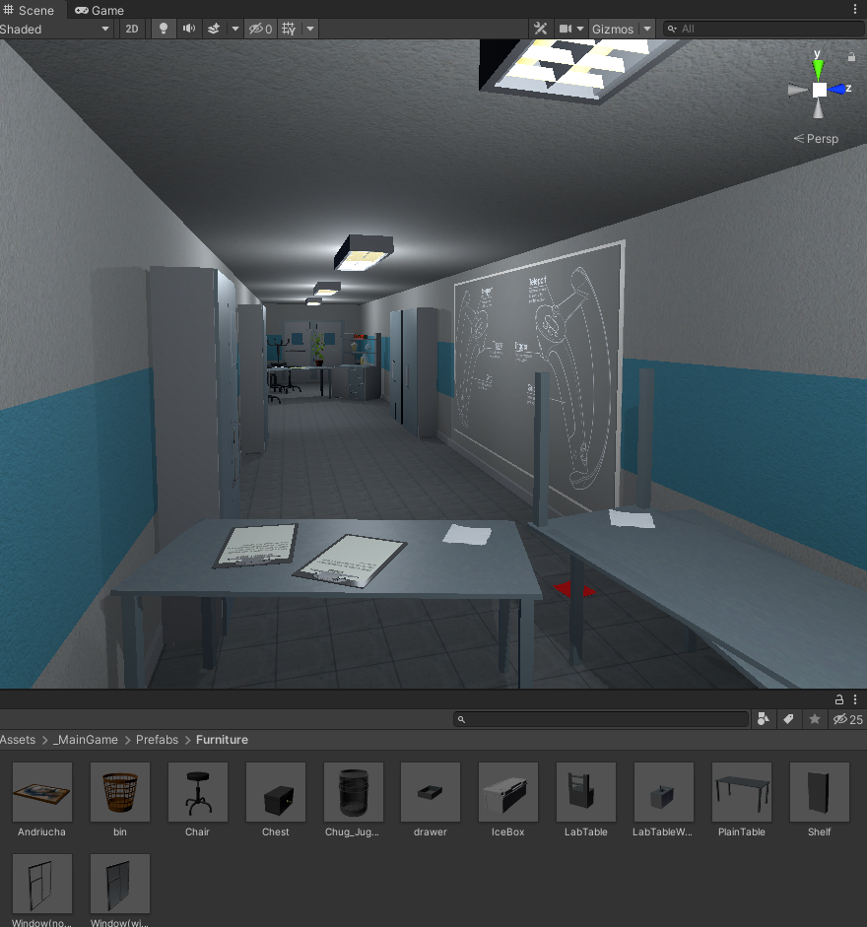

Figure 1. The beginning level scene with some used prefabs below

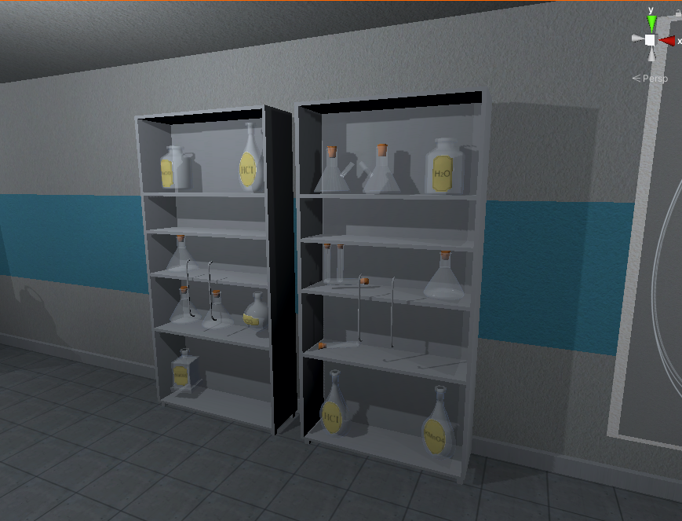

Figure 2. Objects inside of a shelf

**Timer workflow:**

The timer is activated via TimeLeft.cs script component when the player hits a trigger collider (Figure 3). If the timer is over, player loses the game. If the player completes the level during the time limit, the timer stops via StopTime.cs script component.

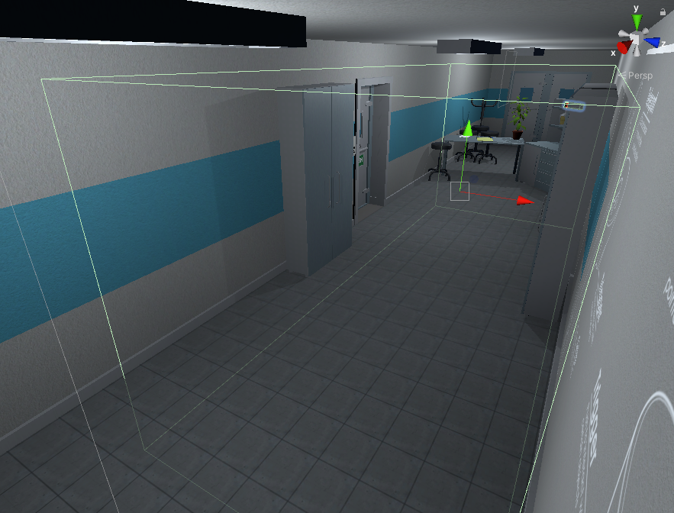

Figure 3. Timer trigger

|  |
| --- |
| public class TimeLeft : MonoBehaviour  {  [SerializeField] TextMeshPro timerMinutes;  [SerializeField] TextMeshPro timerSeconds;  private float stopTime;  public float timerTime;  public bool finalStop = false;  private bool isRunning = false;  private bool check = false;  private void Start()  {  StopTimer();  GlobalData.LevelsTime += timerTime;  }  private void Update()  {  if (isRunning && !finalStop)  {  timerTime = stopTime + (timerTime - Time.deltaTime);  int minutesInt = (int)timerTime / 60;  int secondsInt = (int)timerTime % 60;  timerMinutes.text = (minutesInt < 10) ? "0" + minutesInt : minutesInt.ToString();  timerSeconds.text = (secondsInt < 10) ? "0" + secondsInt : secondsInt.ToString();  if(timerTime <= 0)  {  GameData.SetEnd(true);  GameData.SetVictory(false);  isRunning = false;  }  }  else if(!isRunning && finalStop && !check)  {  OneTimeSend();  check = true;  }  }  public void StopTimer()  {  isRunning = false;  }  public void TimerStart()  {  if(!isRunning)  {  print("timer is running");  isRunning = true;  }  }  public void MinusTime(float seconds)  {  timerTime -= seconds;  }  public void OneTimeSend()  {  //Debug.Log(timerTime.ToString());  GlobalData.Timer.Add(timerTime);  }  } |

Table 1. Timeleft.cs script component

|  |
| --- |
| public class StopTime : MonoBehaviour  {  public LockUnlockWithKey locks;  [SerializeField] TimeLeft time;  // Start is called before the first frame update  // Update is called once per frame  void Update()  {  if (locks.isChestOpen())  {  time.StopTimer();  time.finalStop = true;  //time.OneTimeSend();  }  }  } |

Table 2. StopTime.cs script component

**Door unlocking workflow:**

To pass the level, player has to find a key, which is used to unlock the door. Key and doors have specific tags, which are evaluated. LockUnlockWithKey.cs script component is used to check key GameObject by tag – if the tag is correct, the script component unlocks the door.

|  |
| --- |
| public class LockUnlockWithKey : MonoBehaviour  {  [SerializeField] GameObject[] Note;  [SerializeField] GameObject doorsControll;  [SerializeField] Rigidbody rb;  [SerializeField] string checkKey;  [SerializeField] bool x = false;  [SerializeField] bool y = false;  [SerializeField] bool z = false;  bool isSnapped = false;  IdForUnlock[] unlock;  public bool Open = false;  bool oneTime = true;  bool check = false;  private int unlockId = 0;  bool rigidbodyExists = false;  int index = 0;  [SerializeField] DelegateChange Task;  // Start is called before the first frame update  void Start()  {  doorsControll.SetActive(false);  foreach ( GameObject obj in Note )  {  obj.SetActive(false);  }  if (x)  {  rb.constraints = RigidbodyConstraints.FreezeRotationX;  }  else if (y)  {  rb.constraints = RigidbodyConstraints.FreezeRotationY;  }  else if (z)  {  rb.constraints = RigidbodyConstraints.FreezeRotationZ;  }  }  // Update is called once per frame  void Update()  {  if (!check && isSnapped)  {  unlock = FindObjectsOfType<IdForUnlock>();  if (index < unlock.Length)  {  if (unlock[index] != null && unlock[index].tag == checkKey)  {  int id = Random.Range(1, 20);  unlockId = id;  unlock[index].SetId(id);  check = true;  }  else if(unlock[index] != null && unlock[index].tag != checkKey)  {  index++;  }  }  else if(index >= unlock.Length)  {  index = 0;  }  }  else  {  if (Open == true && oneTime)  {  doorsControll.SetActive(true);  rb.constraints = RigidbodyConstraints.None;  foreach (GameObject obj in Note)  {  obj.SetActive(true);  }  oneTime = false;  rigidbodyExists = true;  Task.AddTask();  Destroy(this);  }  if (isSnapped && unlock[index].GetId() == unlockId)  {  Open = true;  }  }  }  public bool isChestOpen()  {  if (rigidbodyExists)  return Open;  else  return false;  }  public void Snap()  {  isSnapped = true;  }  public void UnSnap()  {  isSnapped = false;  }  } |

Table 3. LockUnlockWithKey.cs script component

## **Task #2. Implement Virtual Reality player movement (in this case, teleportation) (Eligijus)**

The Virtual reality basic controls, such as Teleportation were implemented with the help of VRTK (Virtual Reality Toolkit) plugin. The scripts and mechanics from VRTK are based on script inheritance.

There is a player’s Head at the same position as a VR headset, which is actively tracked. The VR has a zone which is called play area, where player can walk freely until he reaches the end of this zone. If he steps out of the zone, the tracking of headset might be stopped.

**The teleportation workflow:**

First of all, the offset of player’s head and the play area is calculated. After putting a finger on the teleportation button (most of the time it is touchpad button) the program reads one input, which enables curved raycast line. Another input is when the button is being pressed, which teleports the player to the targeted position (the last point of curved raycast line) by calculating the offset of the play area and the last position of the curved raycast line. Later on, the saved offset from beginning is restored and the player is spawned at the pointed location.

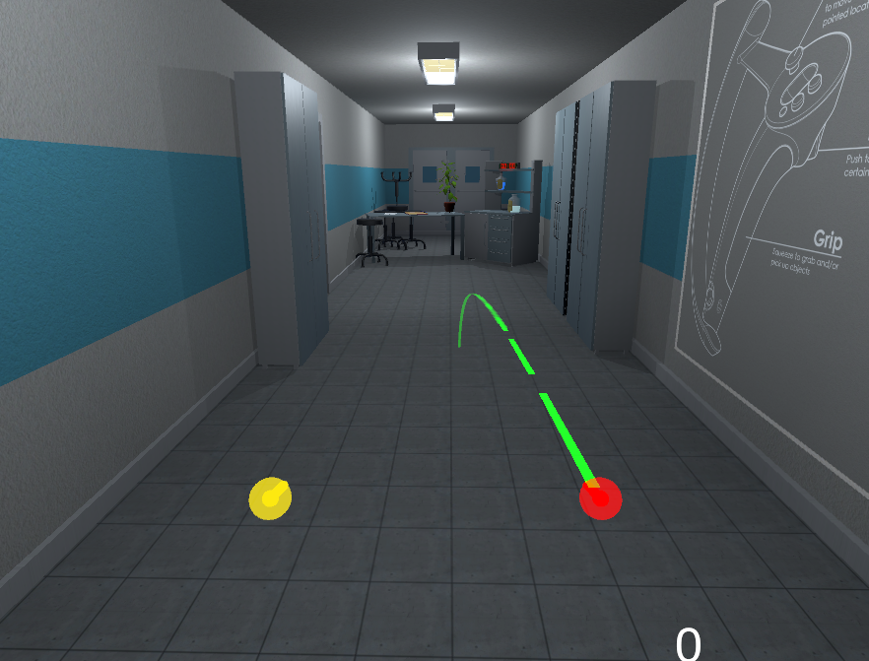

Figure 4. Correct teleportation

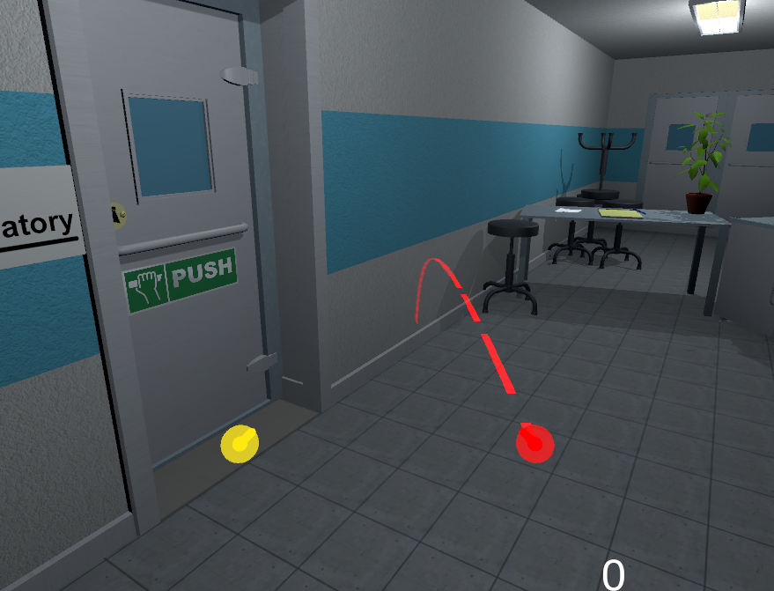

Figure 5. Incorrect teleportation

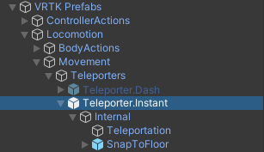

Figure 6. VRTK Teleportation hierarchy

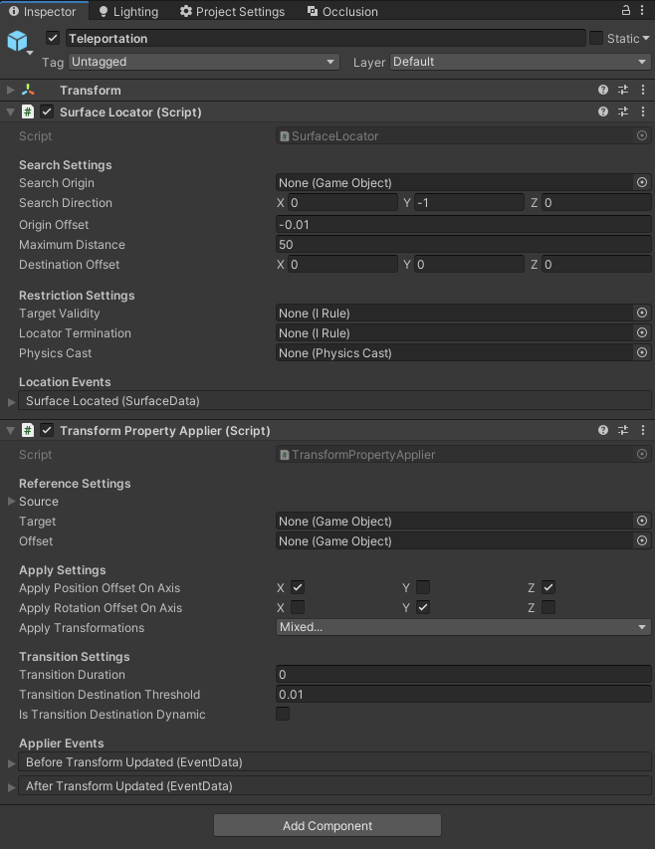

Figure 7. Main teleportation component inspector

## **Task #3. Decorate the level with at least 20 GameObjects, 5 Lights and 5 materials (Airidas)**

The level has been decorated with objects that were modeled in Blender, as mentioned during the first task. Before using these objects inside of the scene, they have been given various components – colliders, rigidbodies, tags, layers, etc.

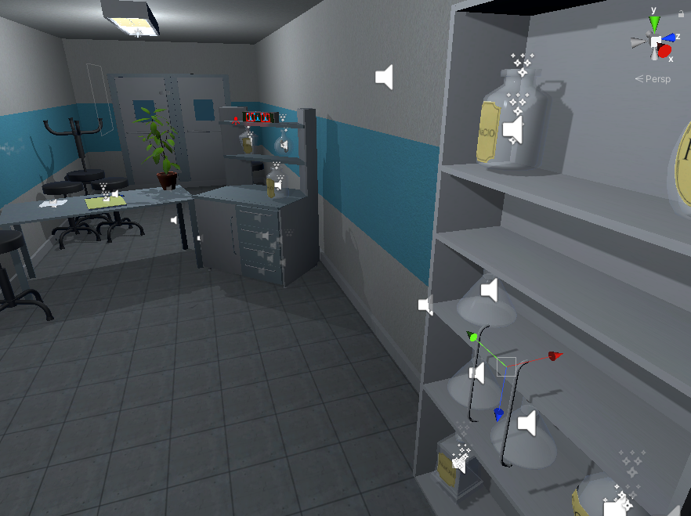

Figure 8. Scene decoration with various GameObjects

Some of the GameObjects that were used in the mentioned scene decoration are are shown at Figures 4-6.

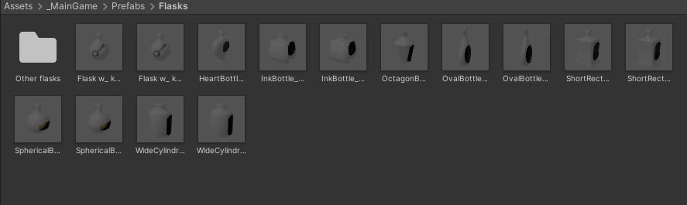

Figure 9. Objects used in the scene #1

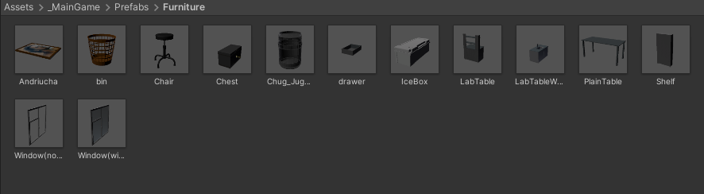

Figure 10. Objects used in the scene #2

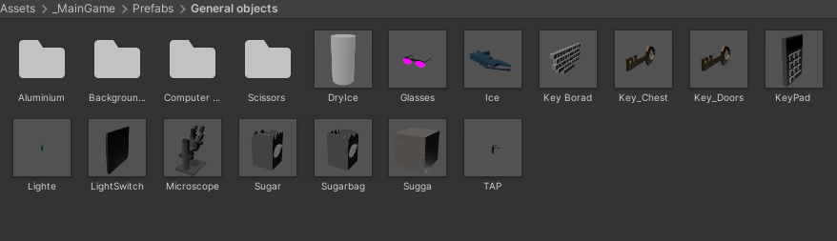

Figure 11. Objects used in the scene #3

The light sources has been made with a few different models.

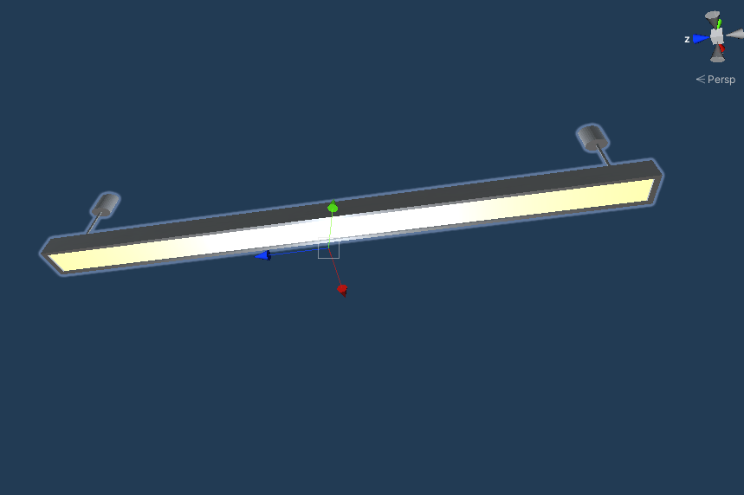

Figure 12. Lamp model #1

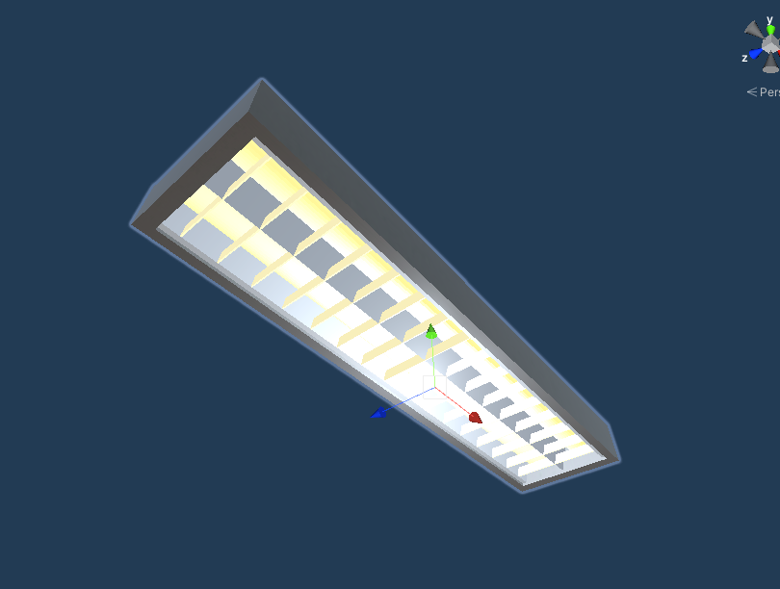

Figure 13. Lamp model #2

## **Task #4. Make a new GameObject, give it a Collider, use onTriggerEnter to track when the Player touches it, then destroy it and print out a message that says “Player touched me” (Eligijus)**

Implemented the functionality by adding DestroyOnTouch.cs script component into GameObject. If this GameObject collides with another GameObject, which has a layer of 10 (which is a player’s Hand), the “Player has touched me” message gets printed out and the object destroys itself.

|  |
| --- |
| public class destroyontouch : MonoBehaviour  {  private void OnTriggerEnter(Collider other)  {  if (other.gameObject.layer == 10)  {  Debug.Log("Player has touched me!");  Destroy(this.gameObject);  }  }  } |

Table 4. destroyontouch script component

## **Task #5. Create UI that displays how many objects were touched (Airidas)**

Implemented the functionality by adding DisplayAtUI.cs script component into GameObject. If this GameObject collides with another GameObject, which has a layer of 10 (which is a player’s Hand), the counter is increased and the textfield is equated to the final counter value.

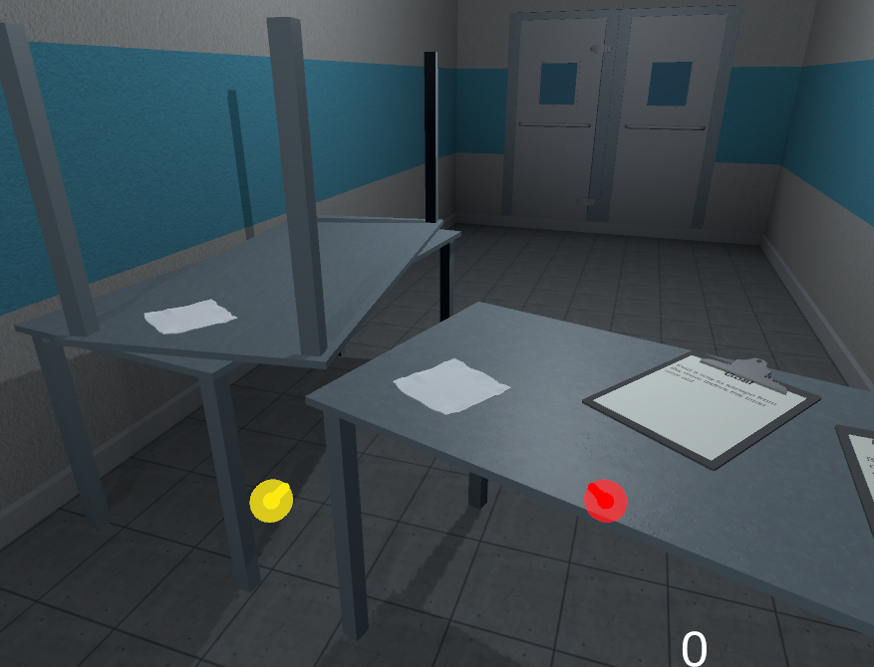

Figure 14. No objects touched

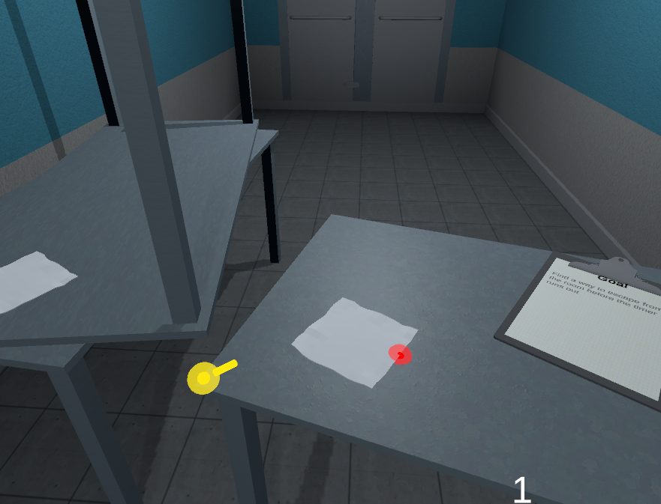

Figure 15. One object touched

|  |
| --- |
| public class DisplayAtUI : MonoBehaviour  {  public TextMeshProUGUI text;  int count = 0;  private void OnTriggerEnter(Collider other)  {  if(other.gameObject.layer == 10)  {  count++;  }  text.text = count.ToString();  }  } |

Table 5. DisplayAtUI script component

## **Task #6. Create a GameObject and make that object jump by pressing spacebar (defense task) (Airidas)**

Created a capsule GameObject, gave it rigidbody and collider components. To implement the jumping mechanic, a Defense.cs script was written and given to the GameObject.

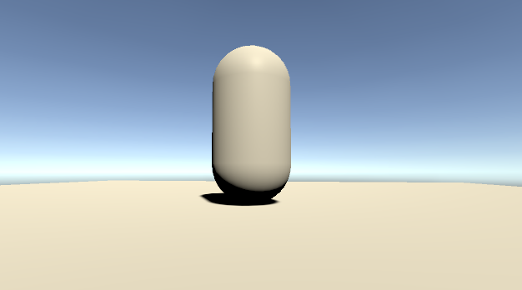

Figure 16. Capsue standing still

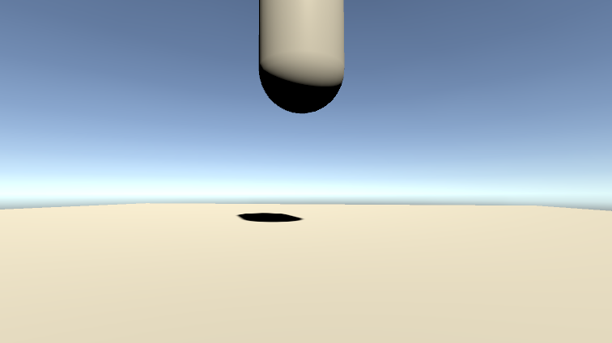

Figure 17. Capsule jumping

The jumping works by adding rigidbody force to the parent GameObject (Table 6).

|  |
| --- |
| public class Defense : MonoBehaviour  {  public float force = 1.0f;  public Rigidbody rb;  void Start()  {  rb = GetComponent<Rigidbody>();  }  void Update()  {  if(Input.GetKeyDown(KeyCode.Space))  {  rb.AddForce(transform.up * force);  }  }  } |

Table 6. Defense.cs script component

# **Literature list**

1. Source #1. <https://vrtoolkit.readme.io/>
2. Source #2. <https://assetstore.unity.com/>
3. Source #3. <https://docs.unity3d.com/Manual/index.html>
4. Source #4. <https://docs.unity3d.com/ScriptReference/>
5. Source #5. <https://unity.com/unity/features/vr>

# **ANNEX**

All source code is contained in this part.

using System.Collections;

using System.Collections.Generic;

using UnityEngine;

using VRTK;

using VRTK.Prefabs.Interactions.Controllables;

public class LockUnlockWithKey : MonoBehaviour

{

[SerializeField] GameObject[] Note;

[SerializeField] GameObject doorsControll;

[SerializeField] Rigidbody rb;

[SerializeField] string checkKey;

[SerializeField] bool x = false;

[SerializeField] bool y = false;

[SerializeField] bool z = false;

bool isSnapped = false;

IdForUnlock[] unlock;

public bool Open = false;

bool oneTime = true;

bool check = false;

private int unlockId = 0;

bool rigidbodyExists = false;

int index = 0;

[SerializeField] DelegateChange Task;

// Start is called before the first frame update

void Start()

{

doorsControll.SetActive(false);

foreach ( GameObject obj in Note )

{

obj.SetActive(false);

}

if (x)

{

rb.constraints = RigidbodyConstraints.FreezeRotationX;

}

else if (y)

{

rb.constraints = RigidbodyConstraints.FreezeRotationY;

}

else if (z)

{

rb.constraints = RigidbodyConstraints.FreezeRotationZ;

}

}

// Update is called once per frame

void Update()

{

if (!check && isSnapped)

{

unlock = FindObjectsOfType<IdForUnlock>();

if (index < unlock.Length)

{

if (unlock[index] != null && unlock[index].tag == checkKey)

{

int id = Random.Range(1, 20);

unlockId = id;

unlock[index].SetId(id);

check = true;

}

else if(unlock[index] != null && unlock[index].tag != checkKey)

{

index++;

}

}

else if(index >= unlock.Length)

{

index = 0;

}

}

else

{

if (Open == true && oneTime)

{

doorsControll.SetActive(true);

rb.constraints = RigidbodyConstraints.None;

foreach (GameObject obj in Note)

{

obj.SetActive(true);

}

oneTime = false;

rigidbodyExists = true;

Task.AddTask();

Destroy(this);

}

if (isSnapped && unlock[index].GetId() == unlockId)

{

Open = true;

}

}

}

public bool isChestOpen()

{

if (rigidbodyExists)

return Open;

else

return false;

}

public void Snap()

{

isSnapped = true;

}

public void UnSnap()

{

isSnapped = false;

}

}

using System.Collections;

using System.Collections.Generic;

using UnityEngine;

using VRTK;

using VRTK.Prefabs.Interactions.Controllables;

using VRTK.Prefabs.Interactions.Controllables.ComponentTags;

public class CloseDoors : MonoBehaviour

{

[SerializeField] GameObject doorController;

[SerializeField] float doorSpeed = 0.05f;

[SerializeField] GroundControll controll;

public Rigidbody rb;

public bool isClosing = false;

bool isGrabbed = false;

//public RotationalJointDrive rotator;

public GameObject rotator;

int count = 0;

// Start is called before the first frame update

void Start()

{

//rotator = doorController.GetComponent<RotationalDriveFacade>();

//rb = doorController.GetComponent<Rigidbody>();

}

private void Update()

{

if (doorController.transform.rotation.eulerAngles.y < 0.002 && doorController.transform.rotation.eulerAngles.y > 0 && isClosing)

{

rb.constraints = RigidbodyConstraints.FreezeRotationY;

Destroy(this);

count++;

}

}

public void Grabb()

{

isGrabbed = true;

}

public void UnGrabb()

{

isGrabbed = false;

}

private void OnTriggerEnter(Collider other)

{

if (other.name == "Head" && count < 1 && doorController.transform.rotation.eulerAngles.y > 1)

{

isClosing = true;

ForceToClose();

Lock();

count++;

Debug.Log(count);

}

}

void ForceToClose()

{

rb.AddForce(transform.right * doorSpeed);

}

void Lock()

{

//controll.coridorOff();

rotator.SetActive(false);

}

}

using System.Collections;

using System.Collections.Generic;

using UnityEngine;

public class StopTime : MonoBehaviour

{

public LockUnlockWithKey locks;

[SerializeField] TimeLeft time;

// Start is called before the first frame update

// Update is called once per frame

void Update()

{

if (locks.isChestOpen())

{

time.StopTimer();

time.finalStop = true;

//time.OneTimeSend();

}

}

}

using System.Collections;

using System.Collections.Generic;

using UnityEngine;

using UnityEngine.UI;

using System;

using TMPro;

public class TimeLeft : MonoBehaviour

{

[SerializeField] TextMeshPro timerMinutes;

[SerializeField] TextMeshPro timerSeconds;

private float stopTime;

public float timerTime;

public bool finalStop = false;

private bool isRunning = false;

private bool check = false;

private void Start()

{

StopTimer();

GlobalData.LevelsTime += timerTime;

}

private void Update()

{

if (isRunning && !finalStop)

{

timerTime = stopTime + (timerTime - Time.deltaTime);

int minutesInt = (int)timerTime / 60;

int secondsInt = (int)timerTime % 60;

timerMinutes.text = (minutesInt < 10) ? "0" + minutesInt : minutesInt.ToString();

timerSeconds.text = (secondsInt < 10) ? "0" + secondsInt : secondsInt.ToString();

if(timerTime <= 0)

{

GameData.SetEnd(true);

GameData.SetVictory(false);

isRunning = false;

}

}

else if(!isRunning && finalStop && !check)

{

OneTimeSend();

check = true;

}

}

public void StopTimer()

{

isRunning = false;

}

public void TimerStart()

{

if(!isRunning)

{

print("timer is running");

isRunning = true;

}

}

public void MinusTime(float seconds)

{

timerTime -= seconds;

}

public void OneTimeSend()

{

//Debug.Log(timerTime.ToString());

GlobalData.Timer.Add(timerTime);

}

}

using System.Collections;

using System.Collections.Generic;

using UnityEngine;

public class BottleSmash : MonoBehaviour {

// Use this for initialization

//all of the required items in order to gie the impression of hte glass breaking.

[ColorUsageAttribute(true, true, 0f, 8f, 0.125f, 3f)]

public Color color;

//to use to find any delta

[HideInInspector]

private Color cachedColor;

//used to update any colors when the value changes, not by polling

[SerializeField]

[HideInInspector]

private List<ColorBase> registeredComponents;

public GameObject Cork, Liquid, Glass, Glass_Shattered, Label;

//default despawn time;

public float DespawnTime = 5.0f;

public float time = 0.5f;

float tempTime;

float clacTime;

public float splashLevel = 0.006f;

public bool colided = false;

//splash effect.

public ParticleSystem Effect;

//3D mesh on hte ground (given a specific height).

public GameObject Splat;

//such as the ground layer otherwise the broken glass could be considered the 'ground'

public LayerMask SplatMask;

//distance of hte raycast

public float maxSplatDistance = 5.0f;

//if the change in velocity is greater than this THEN it breaks

public float shatterAtSpeed = 2.0f;

//if the is disabled then it wont shatter by itself.

public bool allowShattering = true;

//if it collides with an object then and only then is there a period of 0.2f seconds to shatter.

public bool onlyAllowShatterOnCollision = true;

//for the ability to find the change in velocity.

[SerializeField]

[HideInInspector]

private Vector3 previousPos;

[SerializeField]

[HideInInspector]

private Vector3 previousVelocity;

[SerializeField]

[HideInInspector]

private Vector3 randomRot;

[SerializeField]

[HideInInspector]

private float _lastHitSpeed = 0;

//dont break if we have already broken, only applies to self breaking logic, not by calling Smash()

public bool broken = false;

//timeout

float collidedRecently = -1;

LiquidVolumeAnimator lva;

SteamVrSceleton skeleton;

void Start () {

if (Liquid != null)

{

lva = Liquid.GetComponent<LiquidVolumeAnimator>();

}

skeleton = GetComponent<SteamVrSceleton>();

clacTime = time;

tempTime = time;

previousPos = transform.position;

}

//Smash function so it can be tied to buttons.

public void RandomizeColor()

{

color = new Color(Random.Range(0, 1), Random.Range(0, 1), Random.Range(0, 1), 1);

}

void OnCollisionEnter(Collision collision)

{

//set a timer for about 0.2s to be able to be broken

_lastHitSpeed = collision.impulse.magnitude;

if (collision.transform.tag != "Liquid" && collision.transform.tag != "Absorver")

{

//Debug.Log(collision.transform.name);

collidedRecently = 0.2f;

}

}

public void AttemptCollision(Collision col)

{

OnCollisionEnter(col);

}

public void RegisterColorBase(ColorBase cb)

{

registeredComponents.Add(cb);

}

public void ChangedColor()

{

if(cachedColor != color)

{

cachedColor = color;

//update all registered components

foreach (ColorBase cb in registeredComponents)

{

cb.Unify();

}

}

}

public Vector3 GetRandomRotation()

{

return randomRot;

}

public void RandomRotation()

{

randomRot = (Random.insideUnitSphere + Vector3.forward).normalized;

}

public void Smash()

{

skeleton.UnGrab();

broken = true;

//the Corks collider needs to be turned on;

if (Cork != null)

{

Cork.transform.parent = null;

Cork.GetComponent<Collider>().enabled = true;

Cork.GetComponent<Rigidbody>().isKinematic = false;

Destroy(Cork.gameObject, DespawnTime);

}

//the Liquid gets removed after n seconds

if (Liquid != null)

{

float t = 0.0f;

//if (Effect != null)

// t = (Effect.main.startLifetime.constantMin + Effect.main.startLifetime.constantMax)/2;

Destroy(Liquid.gameObject, t);

}

//particle effect

if(Effect != null && lva != null && lva.level > splashLevel)

{

Effect.Play();

Destroy(Effect.gameObject, Effect.main.startLifetime.constantMax);

}

else if (Effect != null && lva != null && lva.level < splashLevel)

{

Destroy(Effect.gameObject, Effect.main.startLifetime.constantMax);

}

else if (Effect != null && lva == null)

{

Destroy(Effect.gameObject, Effect.main.startLifetime.constantMax);

}

//now the label;

if (Label != null)

{

//Label.transform.parent = null;

//Label.GetComponent<Collider>().enabled = true;

//Label.GetComponent<Rigidbody>().isKinematic = false;

Destroy(Label.gameObject);

}

//turn Glass off and the shattered on.

if (Glass != null)

{

Destroy(Glass.gameObject);

}

if (Glass_Shattered != null)

{

Glass_Shattered.SetActive(true);

Glass_Shattered.transform.parent = null;

Destroy(Glass_Shattered, DespawnTime);

}

//instantiate the splat.

RaycastHit info = new RaycastHit();

if(Splat != null)

if (Physics.Raycast(transform.position, Vector3.down, out info, maxSplatDistance, SplatMask))

{

GameObject newSplat = Instantiate(Splat);

newSplat.transform.position = info.point;

}

Destroy(transform.gameObject, DespawnTime);

}

// Update is called once per frame, for the change in velocity and all that jazz...

void FixedUpdate () {

ChangedColor();

collidedRecently -= Time.deltaTime;

Vector3 currentVelocity = (transform.position - previousPos) / Time.fixedDeltaTime;

if ((onlyAllowShatterOnCollision && collidedRecently >= 0.0f) | !onlyAllowShatterOnCollision)

{

if (allowShattering)

{

if (Vector3.Distance(currentVelocity, previousVelocity) > shatterAtSpeed || _lastHitSpeed > shatterAtSpeed)

{

if (!broken)

Smash();

}

}

}

_lastHitSpeed = 0;

previousVelocity = currentVelocity;

previousPos = transform.position;

}

public void ResetVelocity()

{

previousVelocity = Vector3.zero;

previousPos = transform.position;

}

}

using System.Collections;

using System.Collections.Generic;

using UnityEngine;

public class ColbaNoBreaking : MonoBehaviour

{

[SerializeField] float time = 0;

float calTime = 0;

BottleSmash smash;

bool grabbed = false;

// Start is called before the first frame update

void Start()

{

smash = GetComponent<BottleSmash>();

}

// Update is called once per frame

void Update()

{

if (grabbed) {

if (calTime < time)

{

smash.enabled = false;

calTime += Time.deltaTime;

}

else {

smash.ResetVelocity();

smash.enabled = true;

}

}

else if (!grabbed)

{

smash.ResetVelocity();

smash.enabled = true;

calTime = 0;

}

}

public void Grab()

{

grabbed = true;

}

public void Ungrab()

{

grabbed = false;

}

}